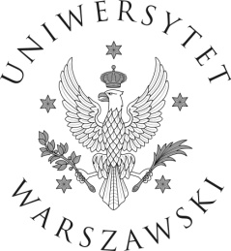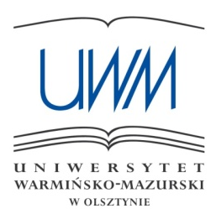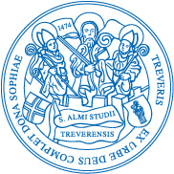

The World of E. M. Forster — E. M. Forster and the World

Olsztyn
29th–30th September 2016

Conference Programme

THURSDAY, 29th September
8:30 – 9:30 | REGISTRATION (Wydział Humanistyczny, ul. Obitza 1, near the main entrance)
9:30 – 9:45 | OPENING (room 37a)
9:45 – 10:45 | Keynote Lecture: Forster on the Screen (room 37a)  Moderator: A. Krawczyk-Łaskarzewska
Claire Monk
Re-valuing Maurice: Novel, Film and Beyond as Transtemporal Transtext
10:45 – 11:00 | Tea break (room 115)
11:00 – 12:30 | session 1: “Only Connect” – E. M. Forster and Other Writers / Media (room 114) Moderator: K. Fordoński
Mihaela Cel-Mare (Avram)
(Re)Visiting E. M. Forster’s Film and Stage Adaptations
Anna Kwiatkowska
What’s Behind Their Umbrellas? Symbolic Consideration of Umbrella
in E. M. Forster’s Howards End and Katherine Mansfield’s Short Stories
Clara Pallejá-López and Lourdes Ilián
Twin Tales: E. M. Forster’s “Another Kingdom” and Max Aub’s “Box”, or When the Nymphs Speak Politics
12:30 – 13:00 | Coffee break (room 115)
13:00 – 14:30 | SESSION 2: Forsterian Echoes in Contemporary Fiction (room 114)  Moderator: H. Zimmermann
Barbara Puschmann-Nalenz
Forster’s The Longest Journey and Maurice – Alan Hollinghurst’s The Stranger’s Child: Sequel or Confrontation?
Robert Kusek
“The ennervated nancy boy of English writing”: E. M. Forster in My Policeman by Bethan Roberts and Arctic Summer by Damon Galgut
Eliza Gładkowska
Endlessly in between: Liminal States in E. M. Forster’s Howards End and Zadie Smith’s On Beauty
14:30 – 16:30 | Lunch break (“Przystań Kortowska”)
16:30 – 17:30 | SESSION 3: The Passage to Italy (room 114)  Moderator: E. Gładkowska
Elena Raicu
A Room with a View: Two Journeys and Two Visions
Tania Zulli
“Worshipping Giotto by the standards of the spirit”: Art and Travel in E. M. Forster’s A Room with a View
17:30 – 17:45 | Tea break (room 115)
17:45 – 18:45 | SESSION 4: The Passage to Italy II (room 114)  Moderator: K. Fordoński
Francesca Pierini Major
Manufacturing Temporal Otherness: The Denial of Coevalness in E. M. Forster’s Italian Short Stories and in Contemporary Relocation Narratives
Raffaella Antinucci
‘Not typically Italian’: Italy Revisited in E. M. Forster’s Arctic Summer
20:00 | Banquet (“Przystań Kortowska”)
FRIDAY, 30th September
10:00 – 11:30 | session 5: Forster’s India – Then and Now  (Moderator: H. Zimmermann)
Sudhir Kumar
Racial Antagonism in E. M. Forster’s A Passage to India
Tarik Ziyad Gulcu
Opposed but Inevitable: Forster’s Reaction Against and Acceptance
of “Cultural Selection” in A Passage to India
Maaz Bin Bilal
The Relevance of E. M. Forster in Contemporary India
11:30 – 11:45 | TEA break (room 14)
11:45 – 13:15 | SESSION 6: Visions of the Future (room 15/16)  Moderator: A. Kwiatkowska
Heiko Zimmermann
Prompter, Inspirer or Prophet? E. M. Forster and the World Wide Web
Sławomir Kozioł
“You mustn’t say anything against the Machine”: Power and Resistance in E. M. Forster’s “The Machine Stops”
N. Cyril Fischer
E. M. Forster and Advertising
13:15 – 14:00 | Meeting of the IEMFS (room 15/16)
14:00 – 16:00 | Lunch break (“Przystań Kortowska”)
16:00 – 17:30 | SESSION 7: Forster in Translations and Contexts (room 15/16)  Moderator: E. Kujawska-Lis
Maciej Adamski
The Car Lost or Saved in the Translation of E. M. Forster’s Howards End into Polish
Marina Alonso Gómez
E. M. Forster in Spanish on Both Sides of the Atlantic: The Spanish Translations of A Passage to India
Grzegorz Moroz
Howards End and Point Counter Point as the Condition of England Novels
17:30 | closing ceremony (room 15/16)
20:00 | dinner (for those who stay in Olsztyn – not included in the fee)

