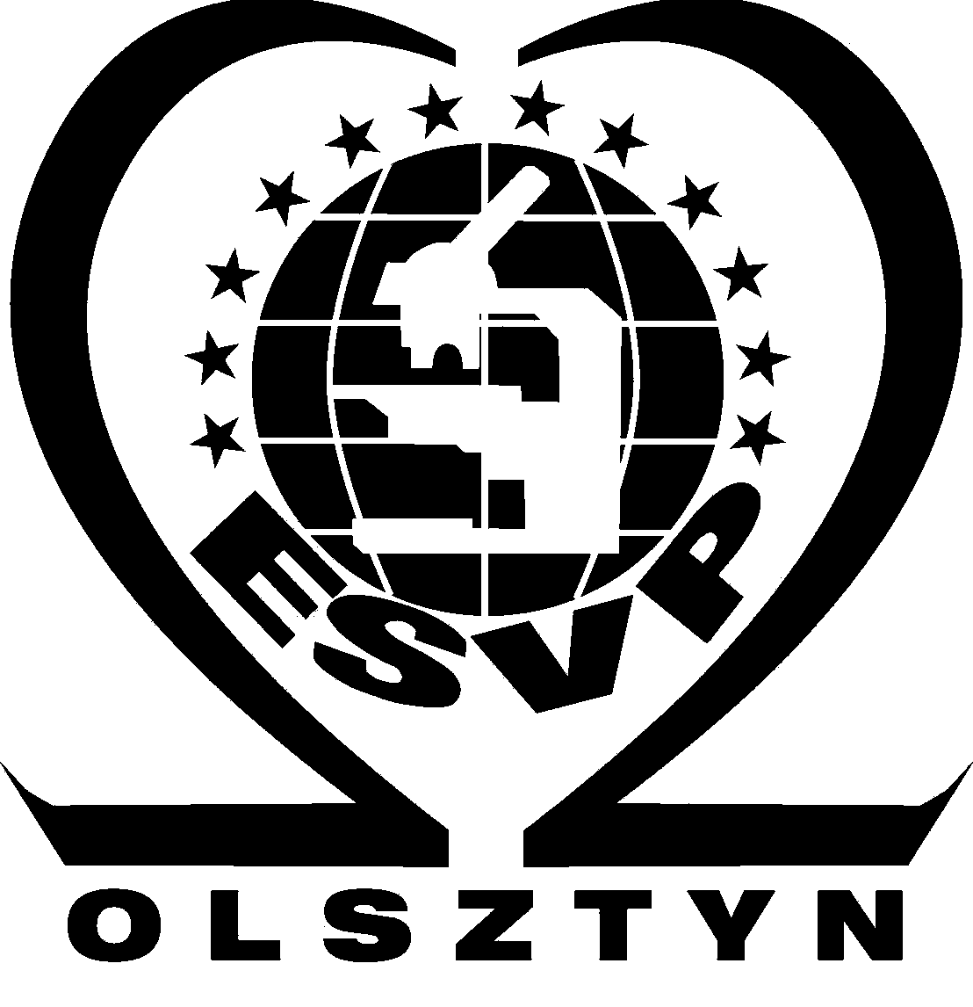 TRANSPORTATION FORM 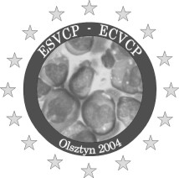

If you would like easier transportation from the Warsaw to Olsztyn and back, you are kindly requested to fill this form and return it to Congress Secretariat by e-mail: esvp@uwm.edu.pl (preferably) or by fax: +48-89-5233252. The Organizers will try to arrange additional express transportation by bus.
Preferable arrival to Warsaw – before 1.00 p.m.
Deadline: May 31st 2004

ACTIVE DELEGATE (please fill in block capitals)
Surname/ Family Name:

First Name:

E-mail address:

ACCOMPANYING PERSON
Surname/ Family Name:

First Name:

ARRIVAL TO WARSAW
Date:

Hour:

Flight No and from:

DEAPARTURE FROM WARSAW
Date:

Hour:

