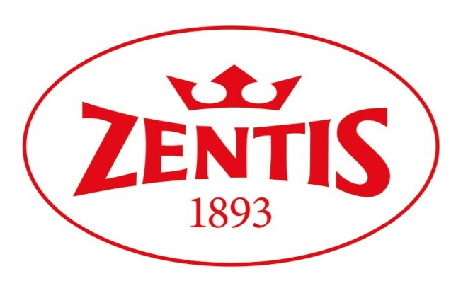

Annex 1

Application Form

to the competition

Snack Lab – health, beauty, condittion on in the rhythm of Zero Waste

…………………………………………………………………………………………………
(full name of competitor)
…………………………………………………………………………………………………
(address details)
…………………………………………………………………………………………………
(year of study, field and specialization) (credit book no.)
……………………………………………………………………………………………......
(e-mail ) (phone number)

Statement:

I hereby certify as follows:

I certify that I have read and understood the Rules of the Competition and I accept its provisions. I myself have created the presentation submitted with the competition “Snack Lab – health, beauty, condittion on in the rhythm of Zero Waste” and I own the copyrights vested therein and I represent that it does not, whatsoever, breach any laws or rights of third parties.

…………………………………………
(printed name of competitor) (place, date)

At the time of the award, I shall transfer on the Organizer the economic copyrights to the said competition materials in the following fields of use: production of copies using print or any other technique, including but not limited to magnetic and digital recording and insertion in computer memory, and I shall transfer on the Organizer free of charge the right to use the materials developed by the competitor as part of the competition as the right to an invention, a utility model or an industrial design.

………………………………………….. ……………………………………
(printed name of competitor) (place, date)

